**Background**

The Wave-Motion Arduino Shield was created by Steven Diemer and Jordan Visser, both juniors enrolled in the Computer Engineering program at Grand Valley State University. As part of a semester long project for EGR-326 (Embedded System Design), an Arduino shield was to be designed and marketed to the public. The shield was largely inspired by the Yak-Bak, a popular toy from the late 1990s that could record audio and play it back at a different frequency/pitch depending on the position of a knob. In principle, the Wave-Motion Shield has much the same functionality as the Yak-Bak. However, the pitch, or frequency, at which the sound is played back, is controlled by the orientation or movement of the shield (of which is measured by an accelerometer).

For those unfamiliar with the Arduino platform, an Arduino is an open-source single-board microcontroller that is designed to make the process of interfacing electronics less painful. In other words, an Arduino allows someone without a strong background in electronics/engineering to control devices like motors, or LEDs without having to understand the complex low-level programming that is typically required to control such devices. Pictured in Figure 1 is an Arduino Uno; the device with which the Wave-Motion Shield was designed to interface.

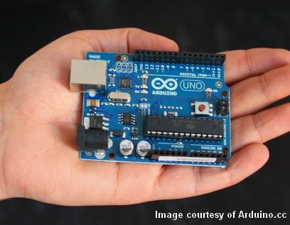

**Figure 1: The Arduino Uno**

The functionality of an Arduino is, of course, limited. As such, many Arduino shields have been designed to provide additional functionality. These “shields” are essentially circuit boards that can be mounted on top of an Arduino. Pictured below is an example of how a shield is physically interfaced with an Arduino.

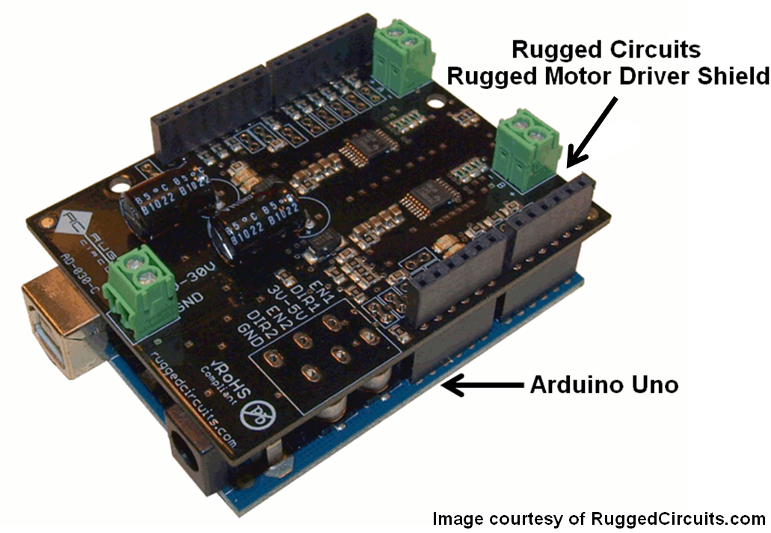

**Figure 2: An Arduino Uno with a Rugged Circuits Motor Driver Shield Attached**

The Wave-Motion shield was designed as a novelty item with the intention of making the software easy to hack to allow for additional functionality. For example, the software could be modified to recognize movements like the beating of a drum and then play back varying drum sounds based on accelerometer readings. This is one example amongst many, and by making the software user friendly, it is hoped that the Arduino Community will use the shield for a variety of sound and motion-based creative endeavors.

***Principles behind the Technology***

*Condenser Microphone*

As the shield required audio recording capability as well as audio playback based on accelerometer readings, a variety of different technologies were utilized. Most central to the operation of the Wave-Motion Shield is its ability to capture audio. To accomplish this, the Wave-Motion Shield first utilizes a small condenser microphone to convert sound, a mechanical wave, into an electrical signal. Figure 3 shows a cross-section of a typical condenser microphone.

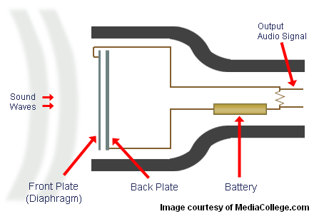

**Figure 3: Cross-Section of a Typical Condenser Microphone**

From Figure 3, it can be seen that a condenser microphone has two plates. The front plate, or the diaphragm, is made out of a very light material which can be moved by a mechanical wave (such as a sound wave) while the back plate is held stationary and tied to some voltage source. These two plates separated by a small distance which, in essence, make a capacitor. The capacitance (*C*) of two parallel plates is described mathematically by equation (1).

$$C= \frac{εA}{s} (1)$$

*Where:*

$$ε=Permittivity \left(\frac{Farads}{meter}\right)$$

$$A=Plate Area ({meter}^{2})$$

$$s=Separation Distance (meter)$$

Holding the plate area and permittivity (the measure of resistance encountered when forming an electric field in a given medium) constant, one can see that a decrease in plate separation distance results in an increase in capacitance, and a increase of separation distance yields a decrease in capacitance. Therefore, as sound waves strike the diaphragm and cause it to vibrate, the condenser microphone’s capacitance changes. When the capacitance increases, more positive charge (supplied by the voltage source) can be stored on the back plate and thus induces more negative charge to accumulate on the front plate, or diaphragm. The inverse is true when the plates move farther apart. This flow of negative charge onto and off of the front plate is electrical current. This changing electrical current constitutes the audio signal from the microphone.

This signal is however very small (typically less than 10mV in peak-to-peak amplitude) and often requires amplification before being used. As such, a microphone pre-amplifier is used in most condenser microphone applications to increase the amplitude of the signal to >1V peak-to-peak amplitude. In the case of the Wave-Motion Shield, the signal is amplified to have a maximum peak-to-peak voltage of 5V. A waveform of this magnitude was desired for the shield as the analog voltage signals are converted to digital values by the Arduino’s ADC (Analog to Digital Converter) which more accurately converts differences in large signals than it can very small signals.

*Audio Playback*

By increasing or decreasing the frequency at which the recorded audio is played back, the pitch of the audio can be increased or decreased. For example, Figure 4 represents a 2kHz sine wave recorded over a 2.5 ms period. This can be thought of as a recording at its native frequency.

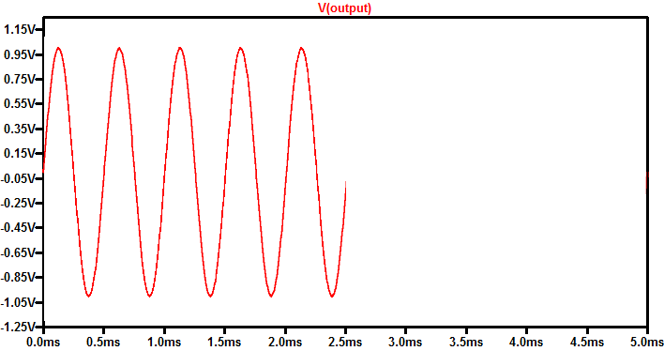

**Figure 4: A 2kHz Sine Wave Representative of a Recording Played Back at Native Frequency**

If this recording were played back at twice the speed it was originally recorded at, the wave would be played back in half the time. By doing this, the original 2kHz sine wave’s frequency is essentially doubled thus manifesting itself as a 4kHz wave when played back. This correlates to a higher pitch during playback in comparison to the native recording. This is depicted visually by Figure 5.

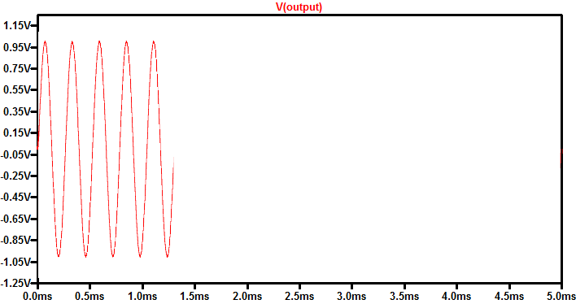

**Figure 5: A 4kHz Sine Wave Representative of a 2kHz Recording Played Back at Twice its Native Frequency**

The opposite is true when the 2kHz recording is played back at half the speed as originally recorded. That is, the wave is played back over 5ms (twice the time of the original recording) which essentially manifests itself as a 1kHz sine wave. This then correlates to a lower pitch playback as compared to the native audio recorded. This is depicted visually by Figure 6.

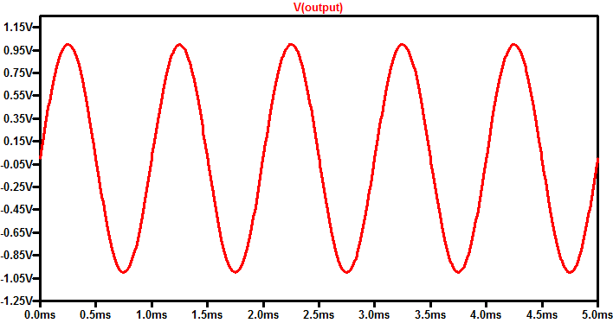

**Figure 6: A 1kHz Sine Wave Representative of a 2kHz Recording Played Back at Half its Native Frequency**

For simplicity’s sake, a sine wave was used to represent how pitch is changed by increasing or decreasing the playback rate. The principle, however, works with any audio signal. View the files below to hear a recording played back at its native recording frequency, 70% of its native frequency, and 150% of its native frequency and notice the change in pitch from the original recording.

Native Playback

Fast Playback

Slow Playback

*Accelerometer*

To analyze the motion of the shield, a 3-axis ±8g accelerometer was used. For those unfamiliar with an accelerometer, it is simply a device that measures acceleration. By using a 3-axis accelerometer, acceleration in the x, y, and z-plane can be measured. In other words, by using this device, the Wave-Motion can detect movement in 3-dimensional space. The device measures acceleration by measuring the force exerted by an internal mass.

The accelerometer used in the Wave-Motion Shield has three outputs; one for acceleration in the x-direction, one for the acceleration in the y-direction, and one for acceleration in the z-direction. The accelerometer outputs an analog voltage in the range 0-2.8VDC at each output depending on its acceleration in the x-, y-, and z-planes (Figure 5). While the device is not moving, voltage readings from x and y output of the accelerometer typically remain at 1.4VDC. Movement in the positive x- or y-direction correlates to the accelerometer outputting voltages on the corresponding channel greater than 1.4VDC (2.8V Maximum). Conversely, movement in the negative x- or y-direction correlates to outputs less than 1.4VDC (0V minimum). The output at the z-axis channel is slightly offset from 1.4VDC while the device is not moving as the accelerometer is measuring some force on its internal mass due to the Earth’s gravity. The output is still fundamentally the same as compared to the other directions as it grows more positive for acceleration in the positive z-direction and becomes less positive for acceleration in the negative z-direction.

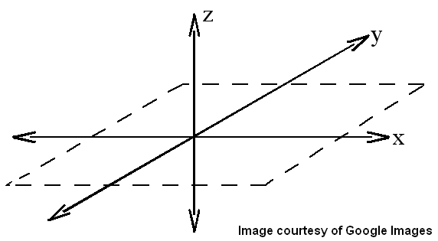

**Figure 7: A 3-Dimensional (xyz) Plane**

By continuously sampling the three output channels on the accelerometer and processing the readings, the motion or orientation of the device can be determined. After determining the device’s orientation or acceleration, the audio playback rate can be adjusted appropriately.

**Using the Wave-Motion**

The Wave-Motion Shield is a plug-and-play device. That is, the device can be used by first powering the Arduino through USB or any other 5VDC source and docking the Wave-Motion on top of it. The device comes pre-loaded with software that allows one to record and playback messages while interfacing with the accelerometer. To record, one simply holds the button on the device labeled “RCRD” until they are done or until the device beeps (indicating end of memory). To play back the recording, simply press the “PLAY” button once and the message will begin to play back. To increase or decrease the playback speed, one simply needs to tilt the device up or down the in x-y plane.

If one wishes to hack or add functionality to the device, the standard pre-loaded code is made readily available on the Wave-Motion WordPress site along with sample code and documentation that demonstrates how to incorporate pattern recognition into the device. This, however, requires that the user download and become familiar with the Arduino IDE.